**Project Audit**

* **FINAL-release**

In the final release of the project, we were able to accomplish the client’s requirements. Clients requirements for this project are monitoring the temperature in the aquarium 24/7, fans to turn on and off when the temperature in the aquarium increases, Android app to monitor the temperature and control the fans, alerts from the app, and auto control to turn and off the LED Lights.

In addition to developing an android app, which provides the client to monitor aquarium temperature and we have provided an alternative by developing a website which has same features to that of the app. Either through this app or Website the client can turn on and off the fans and LED Lights manually as well as automatically. He can receive alerts by providing his email id to the app or website.

The following is the differences between the alpha, beta, and final releases and the breakdown of our step-by-step progress we have made in our project.

Alpha-release

1. Able to run the temperature sensor
2. Acquire temperature readings periodically
3. Data is continuously updated to the cloud
4. Able to set-up a stable system which can detect temperature fluctuations and can automate the functionality of other systems

Beta-release

1. Developed an Android app that can check on the aquarium’s temperature and current state of the fans, has alarm and notification.
2. Added buttons, alarms feature to the app
3. Integrated autonomous fans with smart switch that can be turned on when the temperature reaches 29 °C and turns off at 27 °C.
4. We have developed a website which allows the users to monitor and control the conditions of the aquarium, also has the alarm and notifications, so the users can have the aquarium monitor system on multiple platforms.

Final-release

1. Added data analysis and summary graphical features of state of the aquariums to the Android app.
2. Added autonomous LED Aquarium lights with smart switch.
3. User interface of the app and website improved.
4. Email notification feature has been added.
5. The values in the website and the app can be set by the user and no longer hardcoded
6. Added an extension cable which separates the temperature sensor and the raspberry pi (motherboard)

**Alpha Release:**

In Alpha release we have connected the raspberry pie and along with it the temperature sensor where it is connected to the mother board.

We have created a cloud account for the client which records data from the temperature sensor.

We have demonstrated the working of temperature sensor where it is able to detect temperature and then sends the data to the cloud.

In the cloud the client can see the data stored from the temperature sensor.

**The temperature monitor system on Raspberry Pi:**

We developed the Temperature Logger is a simple Windows 10 Universal Windows Platform app that reads the temperature sensor on the Sense HAT and uploads aggregated data to Azure Table Storage. This app can only run successfully on a Pi with Sense HAT even though you could launch it in any Windows 10 device.

By deploying the autonomous temperature monitor system (Universal Windows Platform app), the sensor can monitor/log temperature from the aquariums and ambient temperature. The Raspberry Pi can send real-time temperature data to the cloud and display them to the LED matrix and the monitor screen. Everything is automatically and real-time.

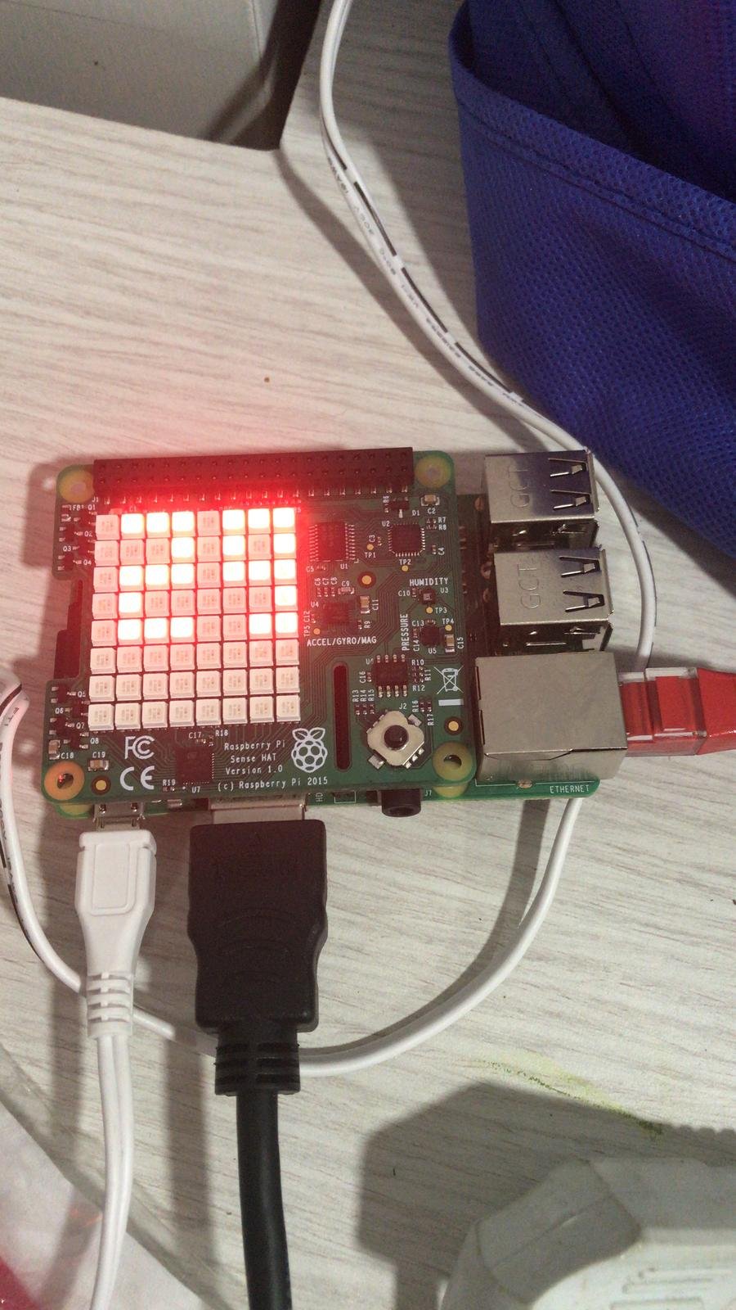

**Real-time temperature data showing on the LED matrix.**

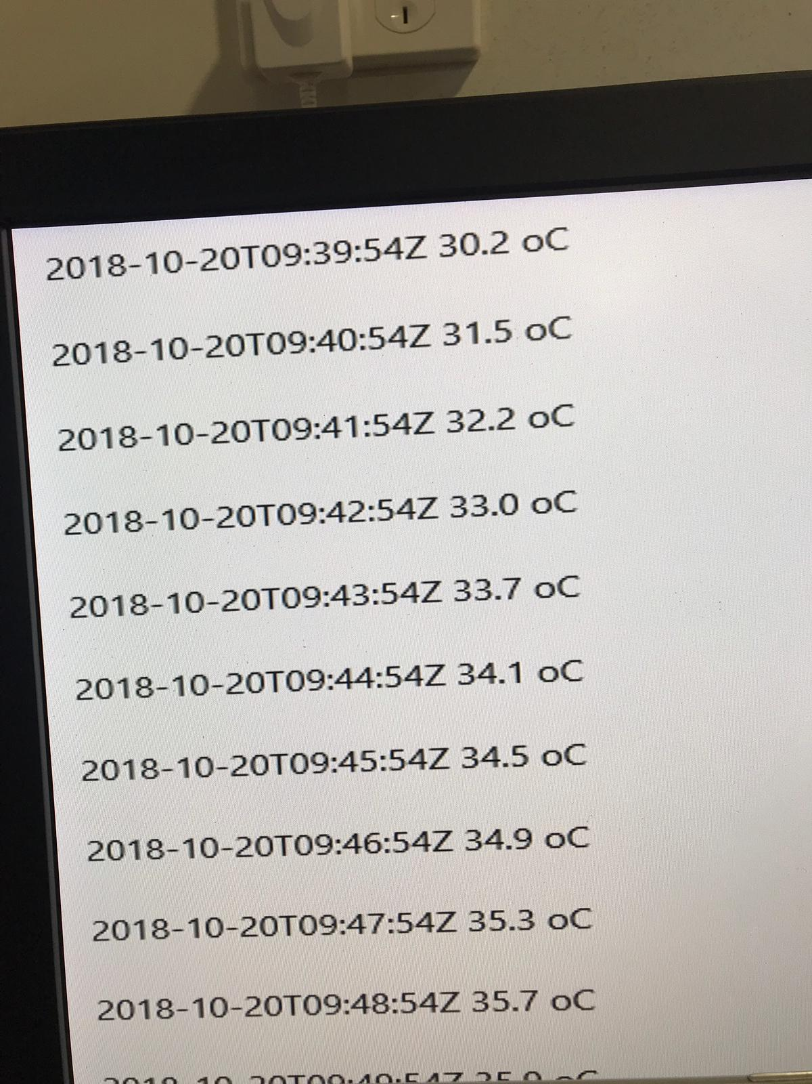

**The temperature data with date and time output from Raspberry Pi on the monitor screen**.

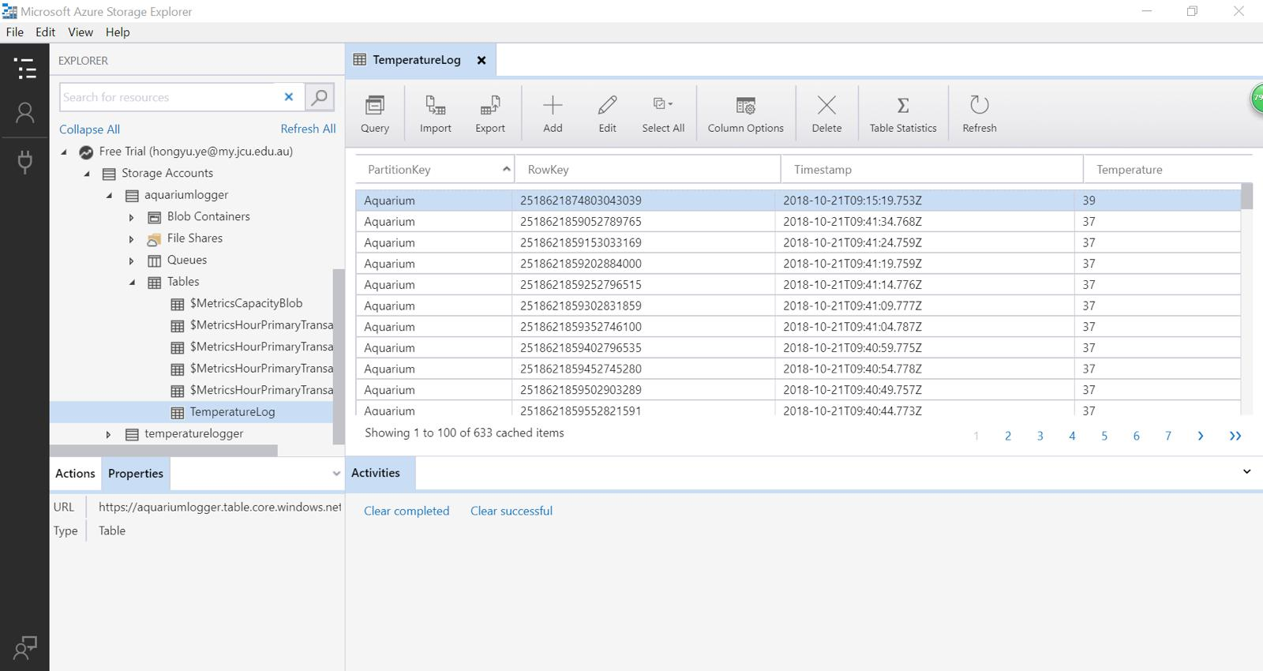

**Data storage on the cloud.**

We also developed the API (Application Programming Interface) of the monitor system to expose the data from the cloud, so we are ready for beta-release. After the publishing of the URL of the API, we can use the URL to allow the Android app to read temperature data from the cloud. We’ve decided to create a .Net Core Web API from scratch. The main logic revolves around converting Date/Time requests to and from the ReverseTicks structure used as the Row Key. Unit tests validate the conversion logic.

**Android App：**

An Android app that can check on the aquarium’s temperature and current state of the fans, control devices, also has alarm and notification.

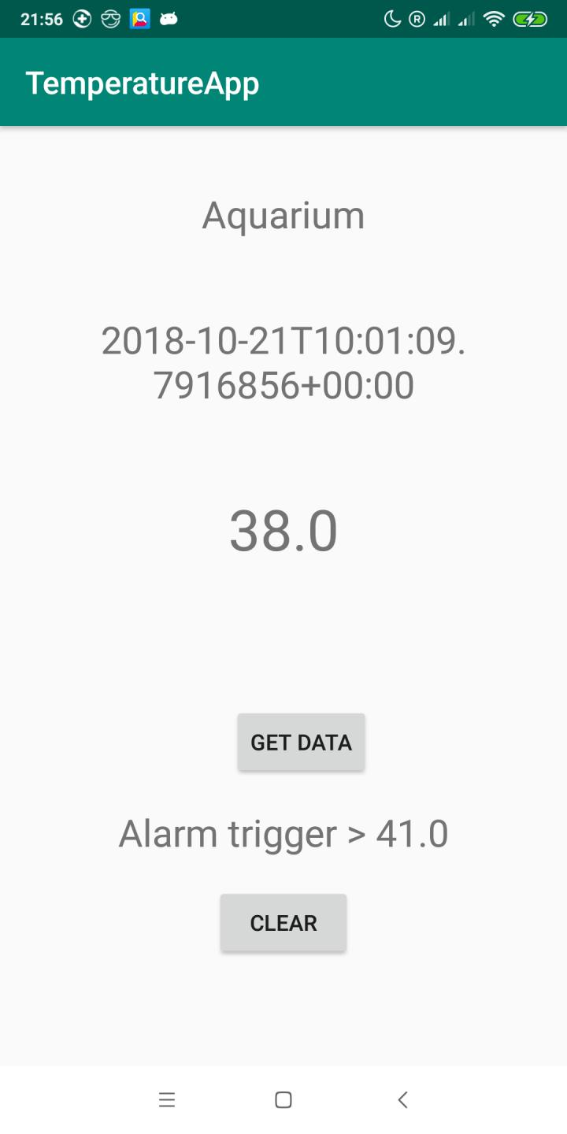

**Beta Release:**

In the beta release we were able to develop a Basic website along with the app, which provides the feature to control the fans manually.

We have approached the client and demonstrated our progress.

**Cooling system：**

Fans with a smart switch that has API and connected to the Internet wirelessly and can be turned on when the temperature reaches 29 °C and be turned off at 27 °C automatically. Users can also control the fan manually.

**Feedback from client After Beta Release:**

Client feedback after the Beta release is that we need to develop the current app and website, if possible to work on the Led Lights and include the access control to the Led Lights in the App and website as well.

Depending up on the time we have the client indicates that he would appreciate any additional features we can add along with the app, website and the fans.

The client suggested that since the temperature sensor is attached to the raspberry pi it may not provide accurate values.

**Assessment of the feedback from the client:**

After getting the feedback from the client, we know that we need work on these aspects of our project.

1. To develop app and website
2. To detach the temperature sensor from the mother board(raspberry pi)
3. To include Led Lights (time dependence and client satisfaction)

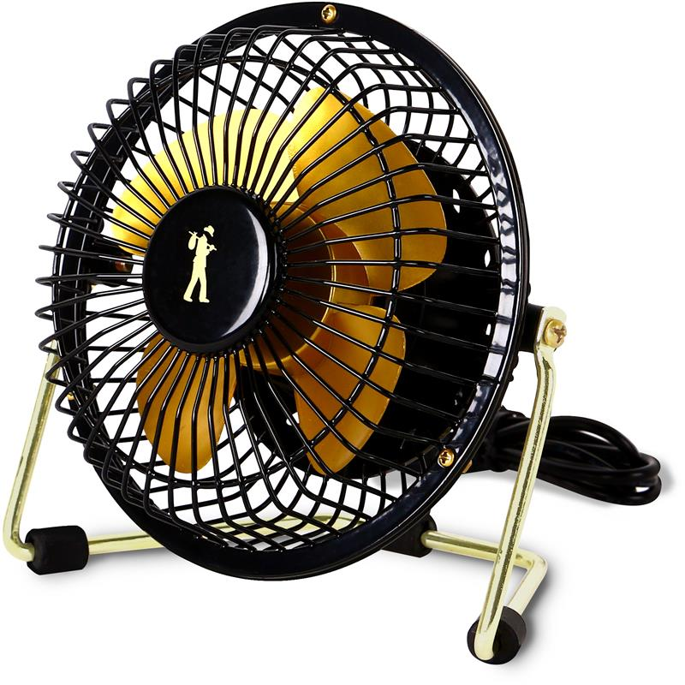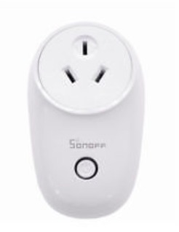

Website:

We make a website for users to control the fan manually and remotely. The smart switch is connected to the Internet wirelessly, that is why the users can control the fan which is connected to the smart switch through our website by an API. We make this newly added website so that the user can control the cooling system whenever and wherever they want on multiple platforms.

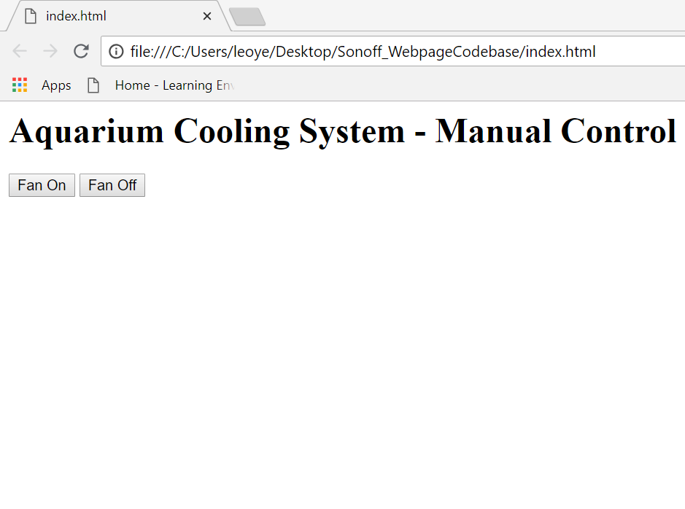

**Final Release:**

Developed version of the App interface:

Live data

Manual control

Automatic control

Settings

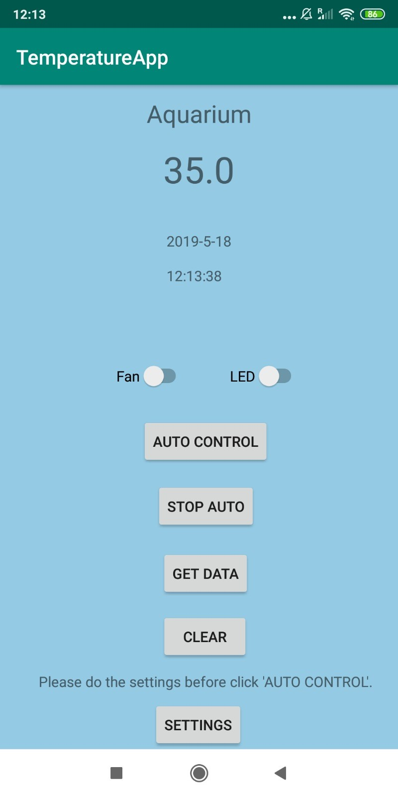

**Settings:**

Client can edit the email address to receive alerts

Can set desired values for both the temperature threshold of fan and the timing of LED light

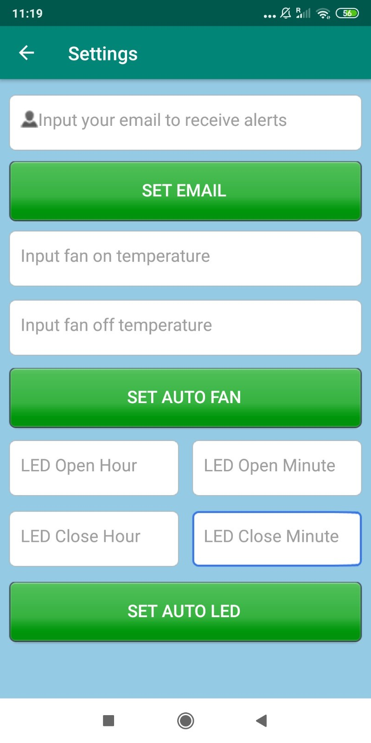

**Email Alert:**

email alert sent to the user after the temperature has exceeded the threshold value set by the user

Alert sent to user automatically.

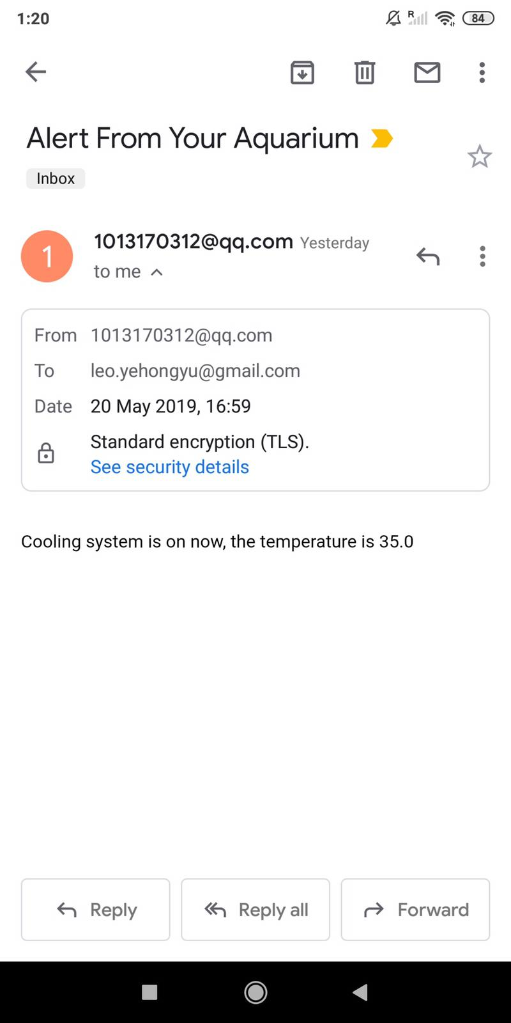

Website which has the same functionalities as the Android app for user to monitor in different devices:

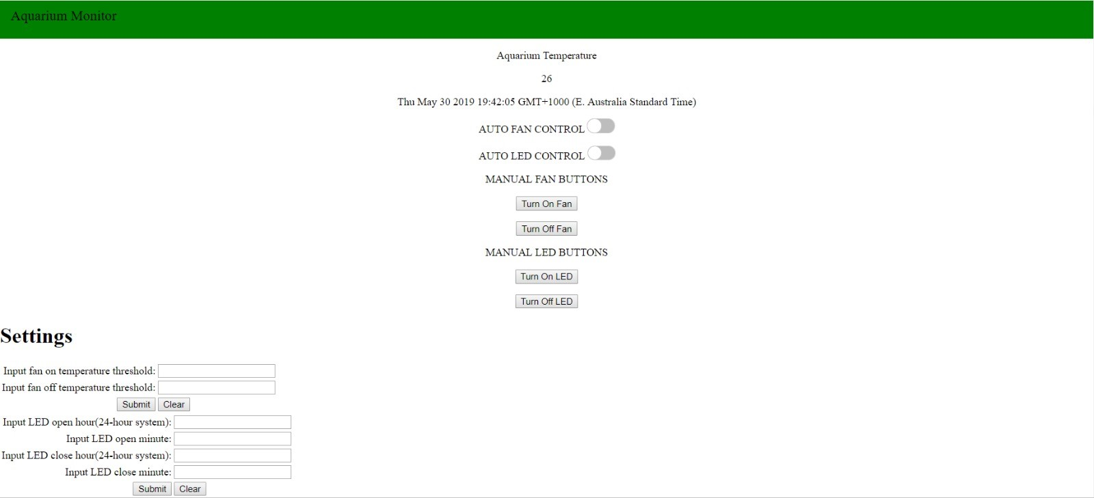

This project relates to Internet of Things, it was developed with Microsoft Visual Studio, Azure and Android Studio using C#, .Net, Java, Javascript, and HTML. It comes with an Android app and a website provide the user with the same features. 1.Monitor the temperature of the Aquarium. Using Raspberry Pi which is a very tiny computer board, it is connected with a sensor that an Android app and website can connect through Internet and monitor/control the aquariums temperature and current status of the fan and LED light 2.The user will be able to operate Manually or Automatically. 3.Manual control of the Fans, LED lights can be done through the app and website 4.Auto control to the fans and LED Lights where the user needs to provide the desired temperature values and if the temperature exceeds the threshold set temperature value the fans will turn on themselves. In LED Lights case, the client needs to set the time for the LED Lights to turn on and turn off. 5. The user can receive alerts and notifications from the app and emails.

The project was for aquariums in tropical Queensland, so I only applied cooling system, no heating system.

In this project I also built a Web API for data communications between the web page, Android app, the cloud, the Raspberry Pi and the smart switch for the cooling system.

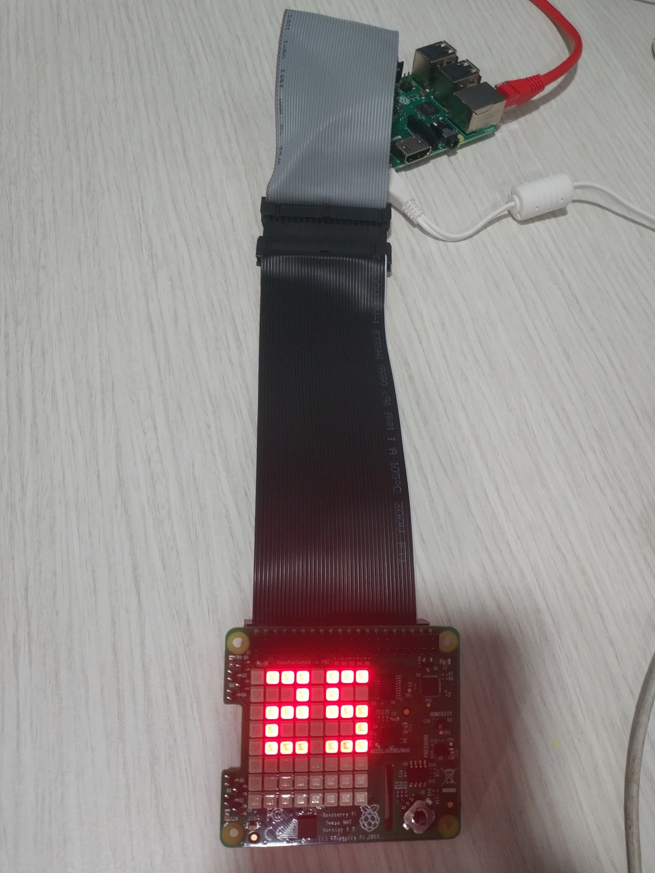

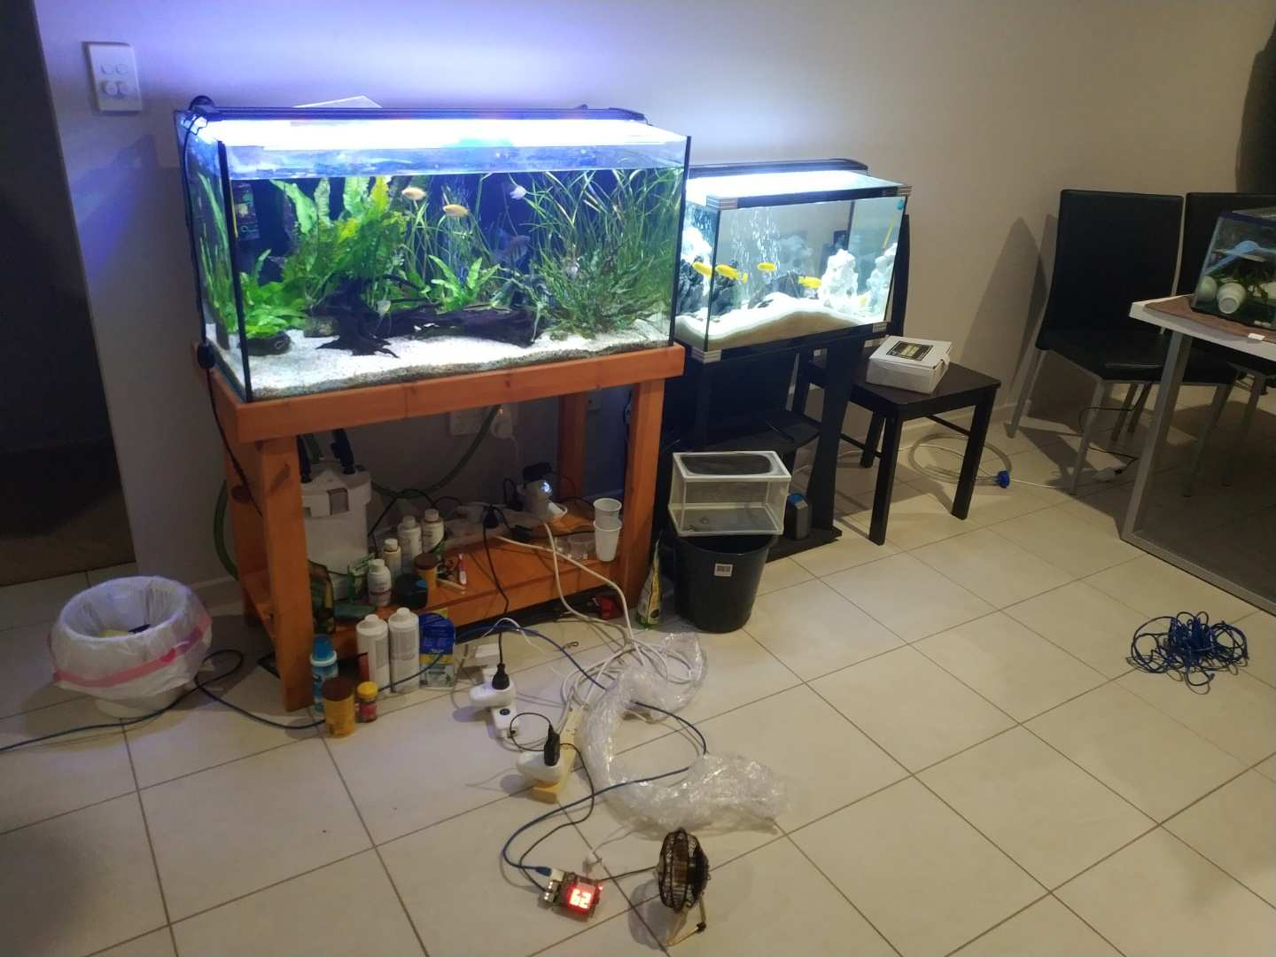

* **Project maintenance ICT infrastructure**

The apk file for installing our Android app can be downloaded from: <https://drive.google.com/open?id=17sBwpKgo60s3IBR1gnvP4bAGfF7jCGmn>

Link of the website: <http://hongyuy.sgedu.site/aquarium_moniter/>

The username/password to view the hosting website files using cPanel:

Username:hongyuy1

Password: xxxxxxx

Host(Primary Domain): hongyuy.sgedu.site

The FTP port is 21.

The source codes can be downloaded from: <https://drive.google.com/drive/folders/1z_7UBRYTsax6QppvVWdLSkGPWhLb2qvU?usp=sharing>

We use the following tools and environment:

1. GitHub is a popular web site and tool which has many usable functions, for example Internet hosting service, version control repository or web-based Git. These functions can offer all kinds of the source code management (SCM) and the distributed version control. Therefore, access control and all kinds of collaboration features, for instance, task management, bug tracking and feature requests became reality. GitHub can be the prefect source code repositories for us.

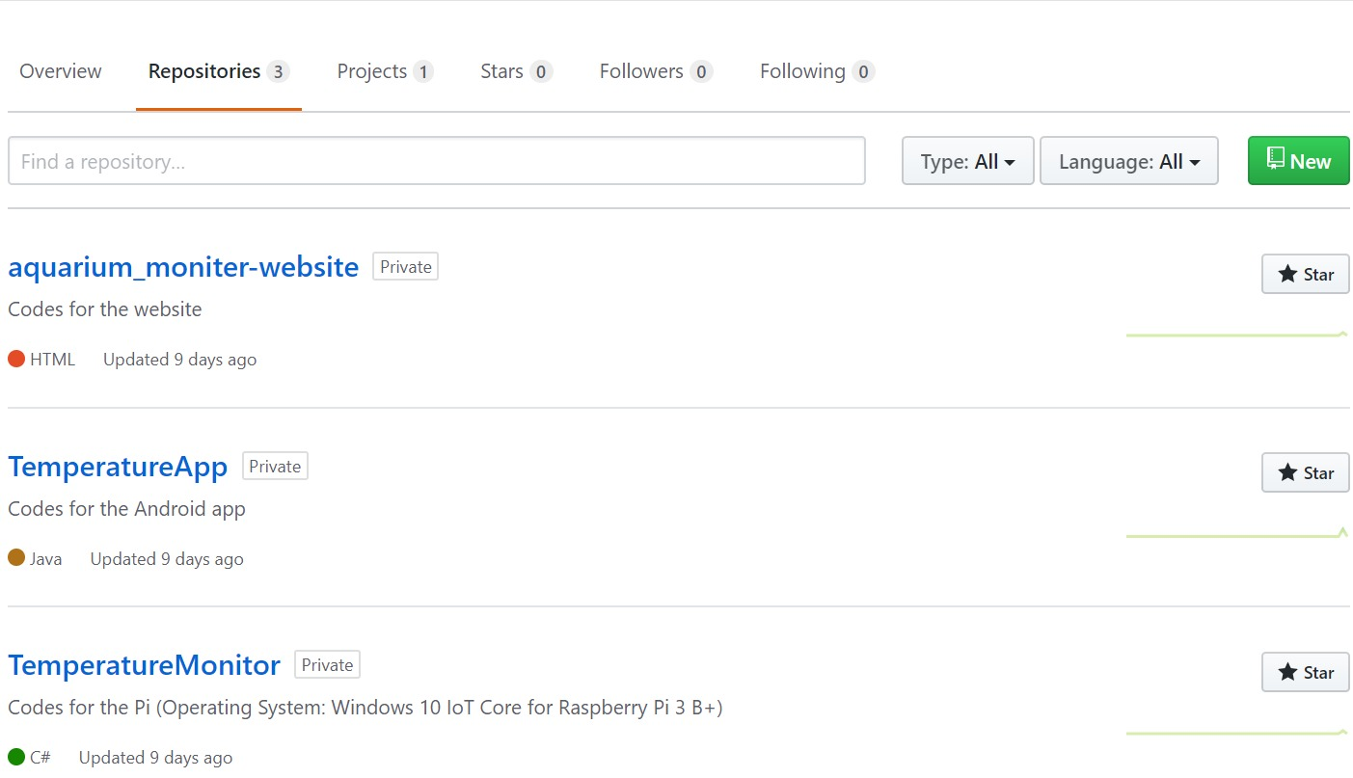

1. Microsoft Azure is a cloud computing service created by Microsoft for building, testing, deploying, and managing applications and services through a global network of Microsoft-managed data centres. We stick to free tiers where possible. The only thing we are paying for is Azure Table Storage and it costs about $0.01 a month even after my sensor has been uploading data for a month. This is the configurations for the cloud to transmit, store and process data, we set up services Microsoft Azure Portal:

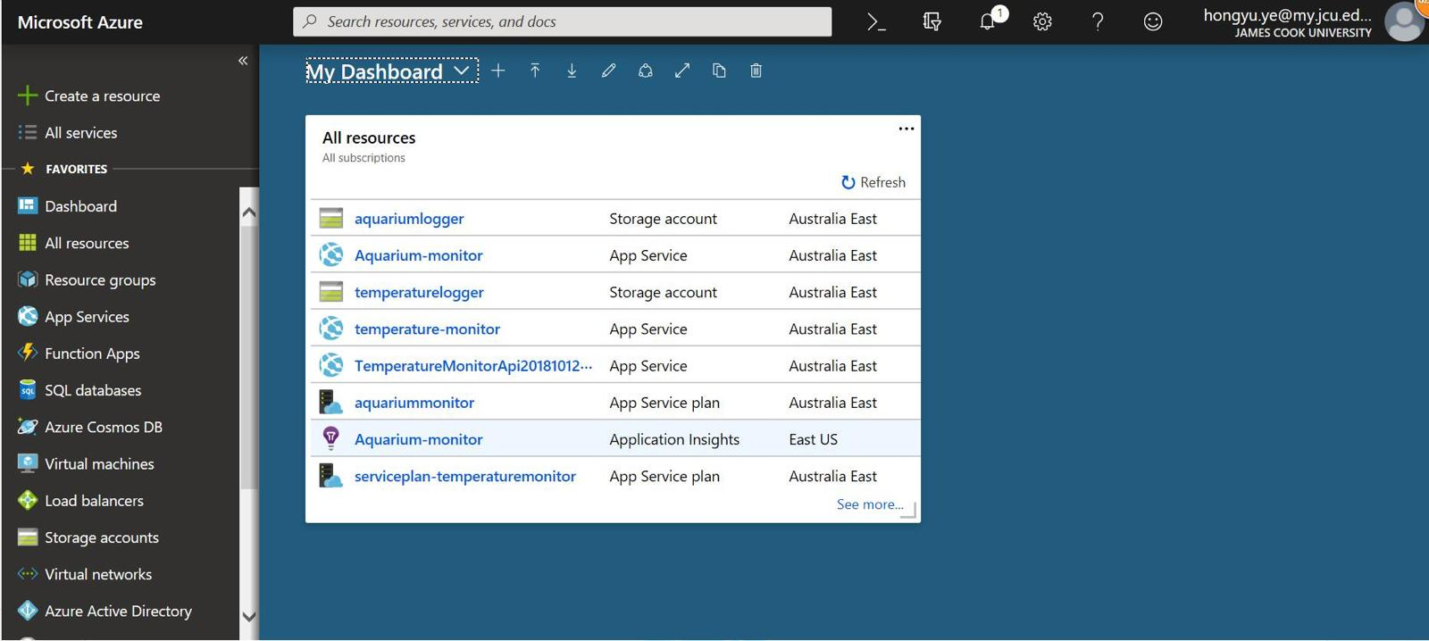

1. Windows 10 IoT Core is a version of Windows 10 that is optimized for smaller devices with or without a display, and that runs on the Raspberry Pi 2 and 3, Arrow Dragon Board 410c & Minnow Board MAX. Windows 10 IoT Core utilizes the rich, extensible Universal Windows Platform (UWP) API for building great solutions.

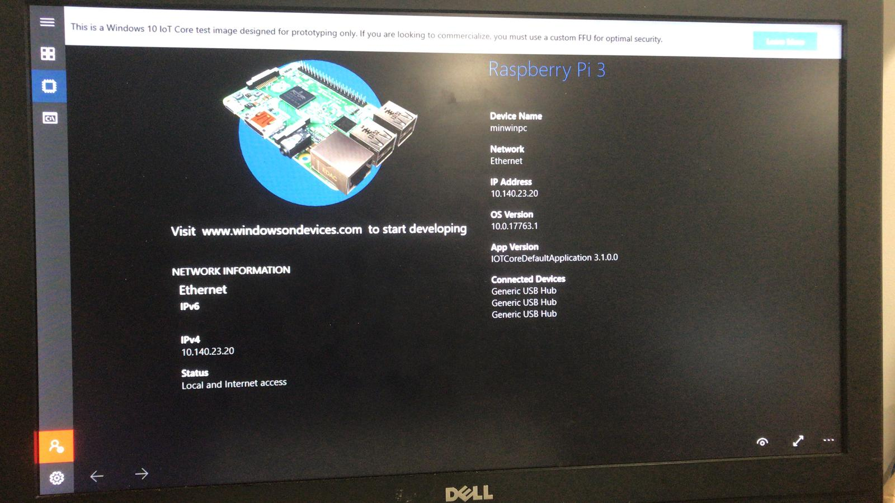

1. Microsoft IoT Dashboard for device configuration and control.

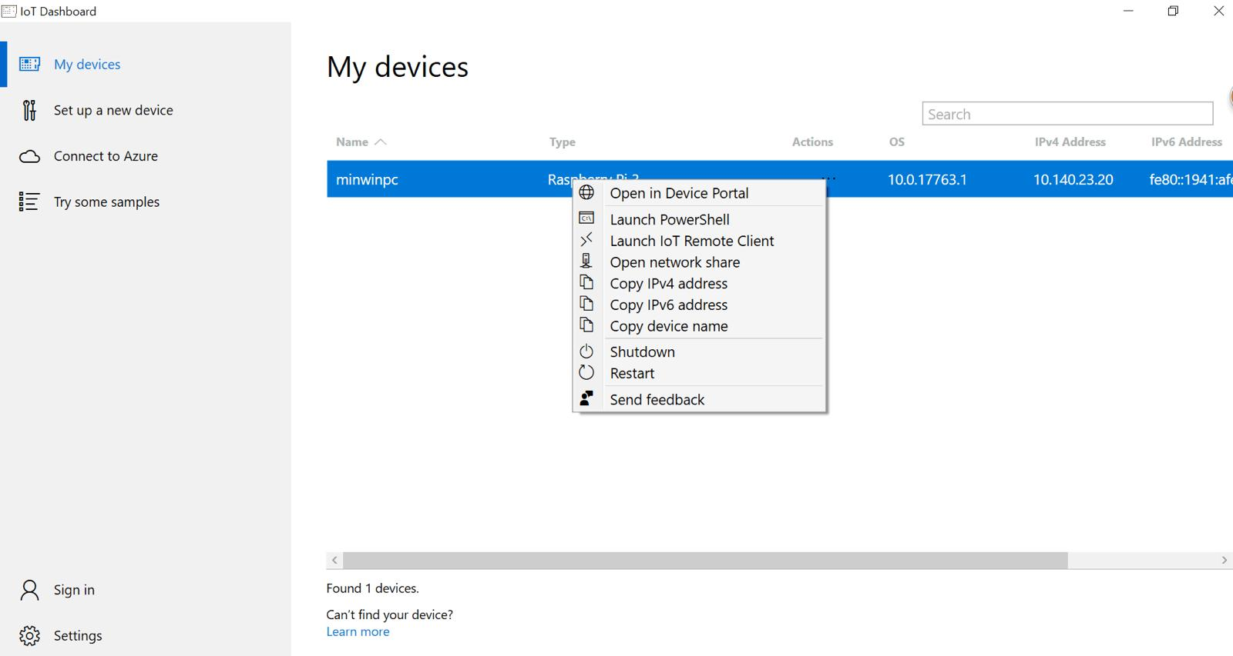

1. Visual Studio 2017 (Windows or Mac) Community Edition and above. Make sure to choose UWP Development and Mobile Development options when installing. We use mostly C# in this.
2. Android Studio is the official integrated development environment for Google's Android operating system, built on JetBrains' IntelliJ IDEA software and designed specifically for Android development. It is available for download on Windows, macOS and Linux based operating systems. We use mostly Java in this.
3. Windows 10 PC or laptop is required to build Universal Windows Platform (UWP) apps, which is the platform Windows 10 IoT uses. A Mac OS computer can be used for all other development tasks in this project.
4. Sense HAT module.
5. 40-pin GPIO ribbon cable to keep some distance between the Pi and the Sense HAT because the Pi’s hot running temperature will affect Sense HAT readings.
6. A Sonoff Smart Switch or alternative smart switch that can connect to IFTTT and Webhooks.
7. Brackets is a source code editor with a primary focus on web development which will be used to develop our new website. We use Javascript and HTML to develop the website.
8. We use the website hosting service called SiteGround and Cpanel to publish our website, the FileZilla is a software of FTP (File Transfer Protocol) is also used to transfer the files of for published website to Cpanel.

Delivered to the client:

Installing the sensor and the Led lights and setting the desired values/

The Client testing and operating through the app and website.

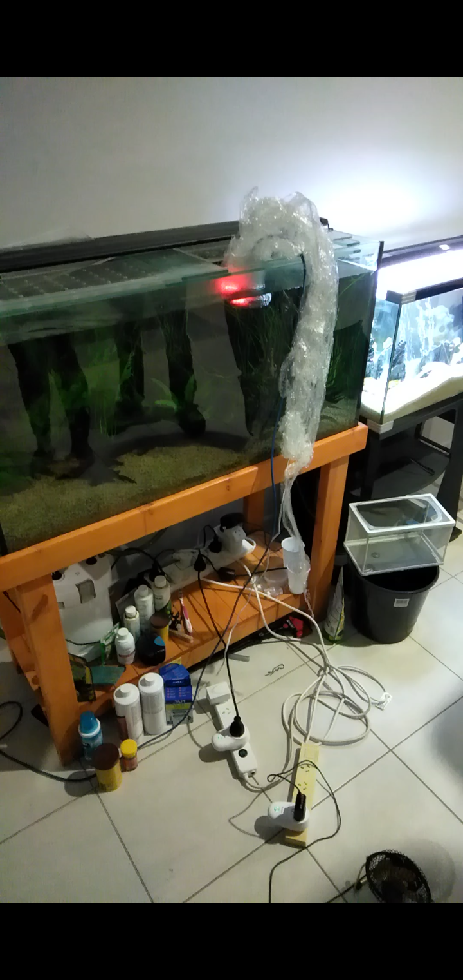

After setting the desired values by the client, the fan and LED lights turned on and off automatically.

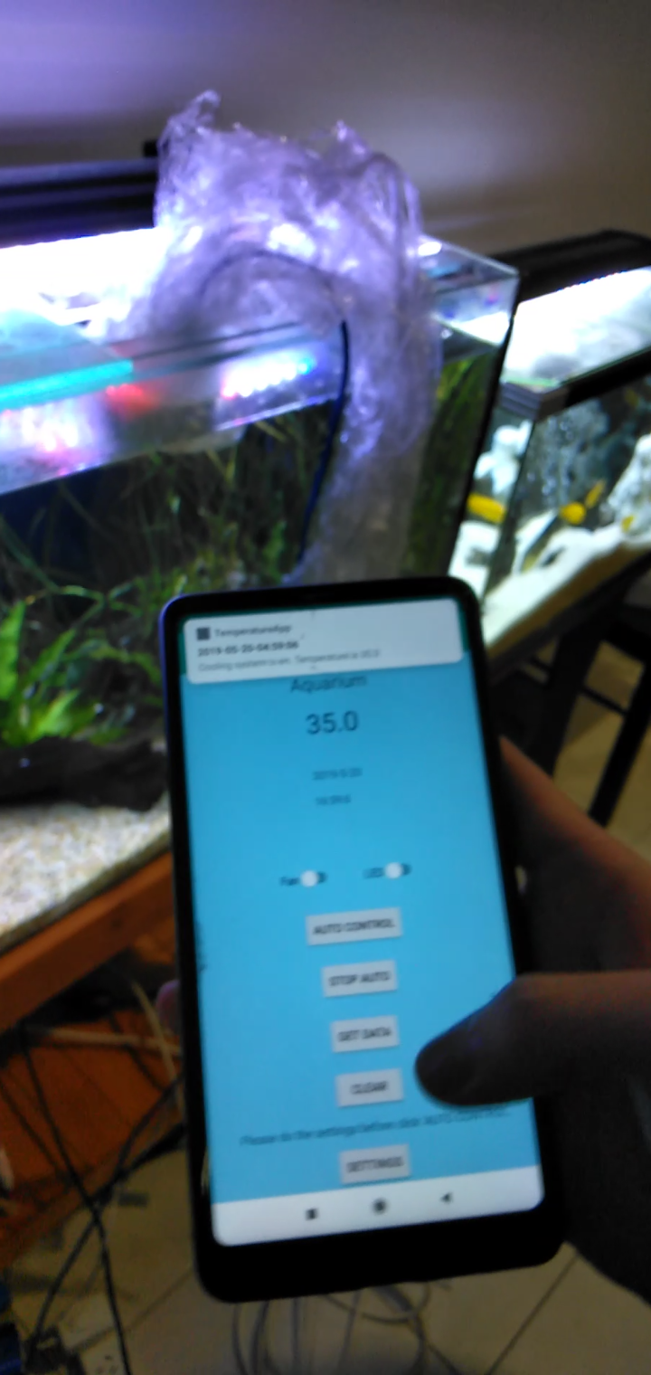

Video demonstration of the procedures can be downloaded from: <https://drive.google.com/open?id=1Adu2xe66ol3FnusXvhEN9rwFLPRy7QKF>